**LIBRARY AND INFORMATION CENTRE**

The library is a resource centre for both teaching and learning. It is housed nearly 13,500 volumes Covering all streams of Science and Engineering, and allied subjects. It has updated collection to the information need of the user community from time to time.  
The library and reference section consist of textbooks, reference books, Dictionaries, Projects report, Previous Question papers, Newspapers, Journals, Magazines and CD/DVDs related to curriculum also provides internet facility. JSSP Library is a member of The National Digital Library of India (NDLI).Staff/Students can obtain the Institute Library membership.

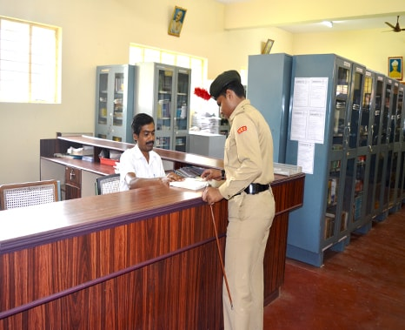

**Library Details:**

|  |  |  |
| --- | --- | --- |
| **SI NO** | **Category** | **Details** |
| **1.** | **Carpet Area of Library (in SQMTS)** | **44 SQMTS** |
| **2.** | **Reading Space (in SQMTS)** | **144/108.36/51.64 SQMTS** |
| **3.** | **Number of seats in Reading Space** | **20** |
| **4.** | **Number of users (Issued book) per month** | **100-120** |
| **5.** | **Number of users (Reading space) per month** | **600** |
| **6.** | **Timings: During Working Day and Weekend** | **Monday – Friday 10AM5.30PM Saturday 10AM – 2PM** |
| **7.** | **Number of Library staff** | **2** |
| **8.** | **Number of Library staff with a degree in library** | **1** |
| **9.** | **Library Management** | **Gurukula** |
| **10.** | **Computerization for Search** | **Yes** |

**Library Sections:**

The library consists of the following sections:

1. Circulation Section
2. Stock Area Section
3. Periodical and Newspaper section
4. Reference Section
5. Digital Resource Center

**Library Resource Collections**

| **Number of Volumes including e-books** | **Quantity** |
| --- | --- |
| **e-books** | **11,600** |
| **CDs** | **50** |
| **Technical Magazines** | **05** |
| **General Magazines** | **03** |
| **Newspapers** | **02** |

**Human Resources for Library**

| **SI No** | **Name** | **Designation** | **Qualification** |
| --- | --- | --- | --- |
| 1. | Yogeesha K S | Library assistant | MLib Sc |
| 2. | Ramesh M | Attender | SSLC |

**Library expenditure on Books, Magazines/Journals, and Newspaper**

| **YEAR** | **Expenditure in Rs** | |
| --- | --- | --- |
| **Books** | **Magazines/Journals/ News Paper** |
| **2022-23 (CFY)** | **8737** | **2880** |
| **2021-22 (CFYm1)** | **19560** | **3000** |
| **2020-21 (CFYm2)** | **83737** | **2880** |

**Digital Resource Center:**

Library’s Digital center is having a good collection of e-books.

**Current Awareness Service(CAS):**

This service provides the latest information to users in the area of Science and Technology and Engineering.

**Internet Facility:**

10 PCs are available for the users to browse the internet.

**New Arrival Display:**

In the New Arrival section, one copy of the new title or new edition is displayed for one Month for attracting the students and staff members for using the library effectively and at The same time upda  
their knowledge.

**Rules and Regulations of the Library:**

* Students should register their name in the Login Register.
* The personal belongings should be kept in track while entering the library.
* Only blank sheets of paper are allowed inside the library for taking notes.
* Students asked to maintain silence and discipline in and around the library.
* Students are asked to switch off their mobile or keep it in silent mode.
* All the students are eligible to borrow books.
* Borrowed books should be returned before the due date.
* Before leaving library with borrowed books, the student is asked to check the condition of the books.
* If any pages are found missing or torn or any other damage found by student at the time of issue, it should be reported to the librarian.
* If the borrowed book is lost, the concerned student should Report about the book to the librarian. He/she should replace the same title, author edition and publication with fine. Otherwise, The concerned student should pay two times cost of the book.
* If any student is found to be involved in stealing or destroying/damaging any type of reading Materials, he/she is penalized.
* No library item shall be taken out of the library without due procedure.